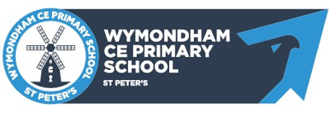
2023 – 2024 Year Planner
Year 3&4
Cycle B | Autumn Term |  | Spring Term |  | Summer Term
Cycle B | Term 1  7 weeks | Term 2  9 weeks | Term 1  6 weeks | Term 2  4 weeks | Term 1  7 weeks | Term 2  6 weeks
English  (SPAG) | Word Classes  Determiners  Conjunctions | Sentence Structures  Expanded noun phrases | Adverbs  Prepositions  Tenses | Speech  Adverbial Phrases  Tenses | Paragraphs  Sentence Structure | Consolidation
English  (Writing) | Baseline (Journey)  Narrative (Traditional Tales)  NCR | Persuasive  Narrative  Poetry | Poetry  NCR | Narrative  Instructions | Narrative  Persuasive | Poetry  Narrative  Persuasive  Biography
Maths | Place Value  Four Operations | Four Operations | Multiplication and Division  Length and Perimeter | Fractions  Mass and Capacity | Fractions  Money  Time | Shape  Statistics
Science | Sound | Digestion and Teeth | Electricity | States of Matter | Plants | -
Geography | Rivers | Coasts | The Americas | - | Earthquakes and Volcanoes | -
History | The Tudors | Ancient Egyptians | Vikings | - | The Roman Empire | -
Art and DT | DT | Still Life | DT | Sculpture | Light | DT
RE | What does it mean if Christians believe God is Holy? | Why do some people believe in God and some not? | Why is the Torah important to Jewish people? | What do Christians believe Jesus did to save people? | For Christians, what kind of king is Jesus? | Why do Hindus want to be good?
PSHCE | Me and My Relationships | Valuing Difference | Keeping Myself Safe | Rights and Responsibilities | Being My Best | Growing and Changing
Computing | Inside a Computer  E-Safety | Internet research | E-Safety | Programming | Programming | PowerPoint

